- Purpose

The purpose of this procedure is to outline the steps necessary to complete the shift cleaning of the centrifuge system in the Production Room.

- Scope

This procedure applies to centrifuge system at the Manufacturing Facility. This cleaning should be completed twice a shift.

- Responsibility

Lead Operator or designee

- Safety Considerations

Safety glasses and appropriate safety apparel are to be worn at all times.

Safety is a condition of employment. Employees are not authorized to work in an unsafe manner and are prohibited from harming the environment of the facility or community.

- Materials/Equipment

N/A

- Procedure

This Preventive Maintenance and/or Repair procedure should be conducted only by and/or under the direct supervision of the Lead Operator of the shift. This has a direct impact on production and is critically important for schedule completion to be completed in a timely manner.
- Divert feed from the centrifuge being cleaned to the sample pot located directly behind Centrifuge #1.
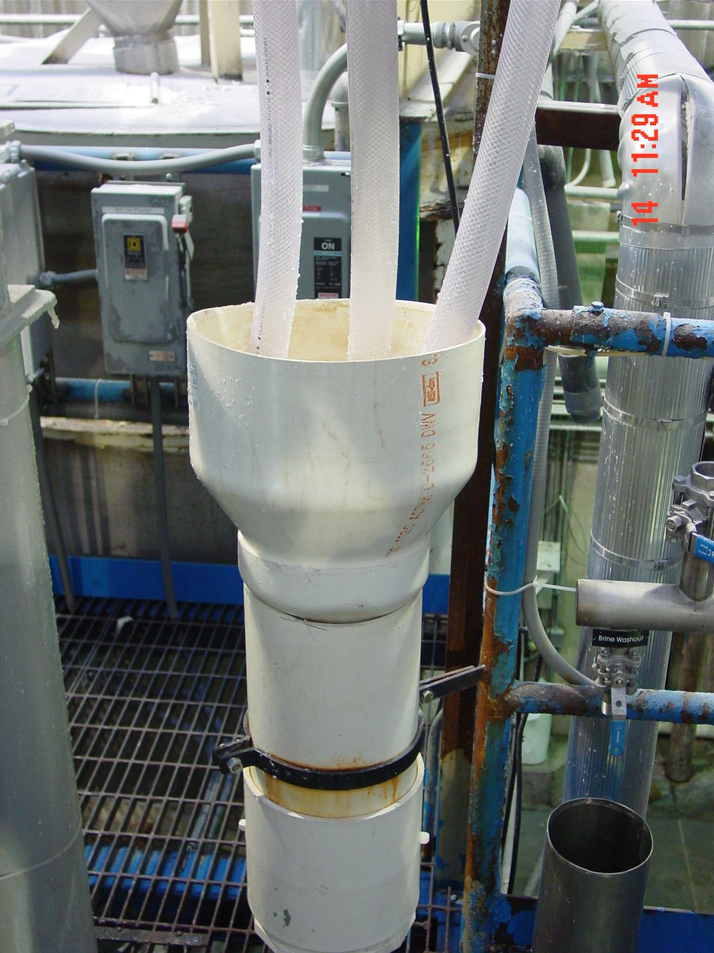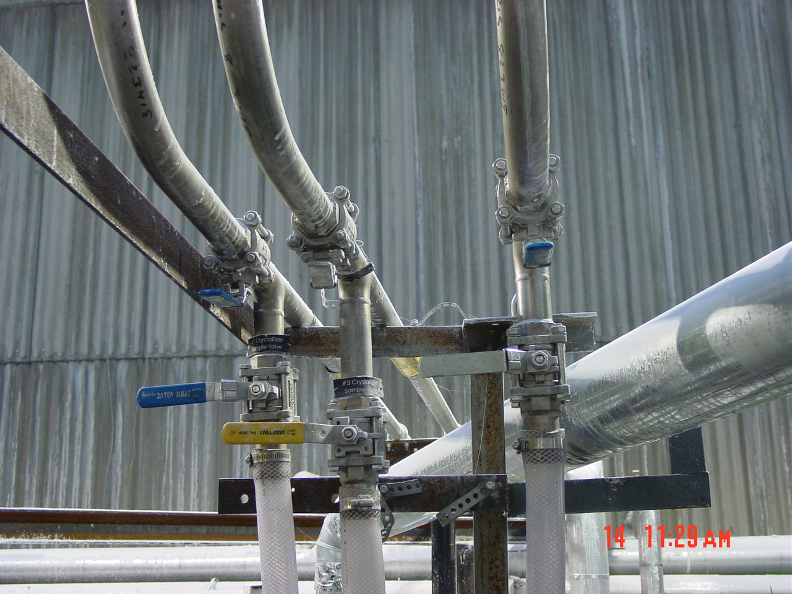
- Allow several minutes for the salt to clear the centrifuge in operation and the centrifuge screw. Then open the center door of the screw and both side doors of the screw and initiate closing of the dryer gates and the opening of the gate that feeds the Mother Liquor Pot (see Figure 1). Very important to ensure that the water washout valve is on (see Figure 2) to flush the Mother Liquor Pot feed gate and clear it so that water will drain. May require hot hose use to ensure that drain is open before moving forward.
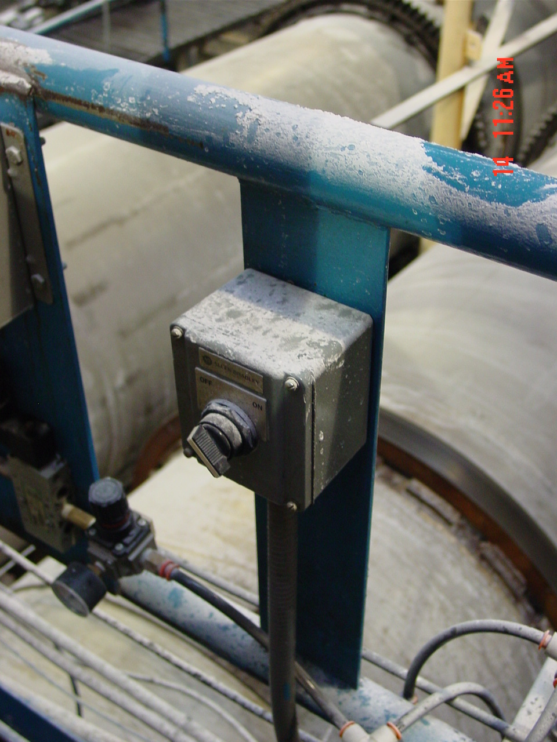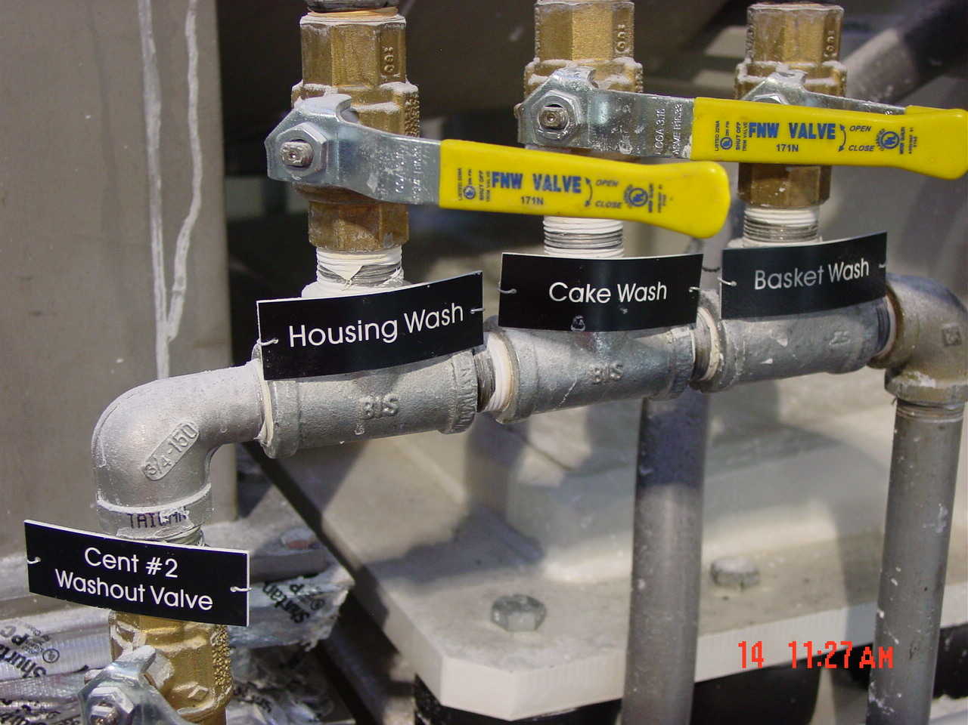
Figure 1 Figure 2
- Next cut on the housing wash valve (Figure 1) located to the right of the centrifuge being cleaned and allow water to flush for two to three minutes. Lift gate and using hot hose clean underneath centrifuge and screw (Figure 2 illustrates Centrifuge #2). Cut housing wash off and repeat flush cycle for two to three minutes each for the cake wash and basket wash.
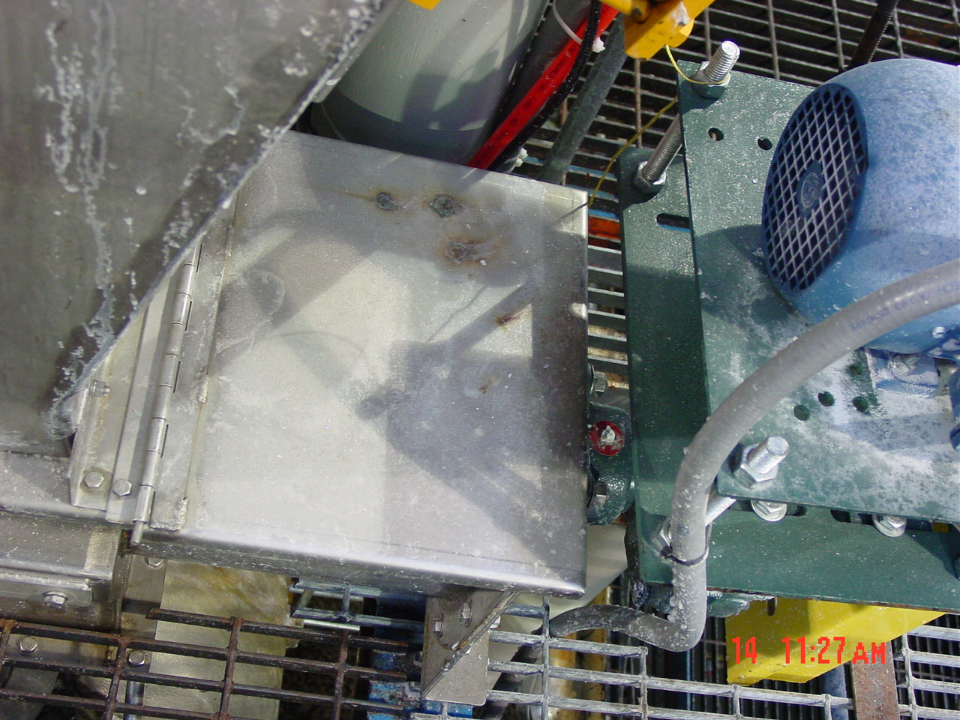
Figure 1 Figure 2

- Wash all areas of centrifuge screw using both forward and reverse of screw (Selector switch Figure 3) to ensure complete cleaning of screw. Again, hot hose required to ensure proper cleaning within screw (Figure 1 and 2).
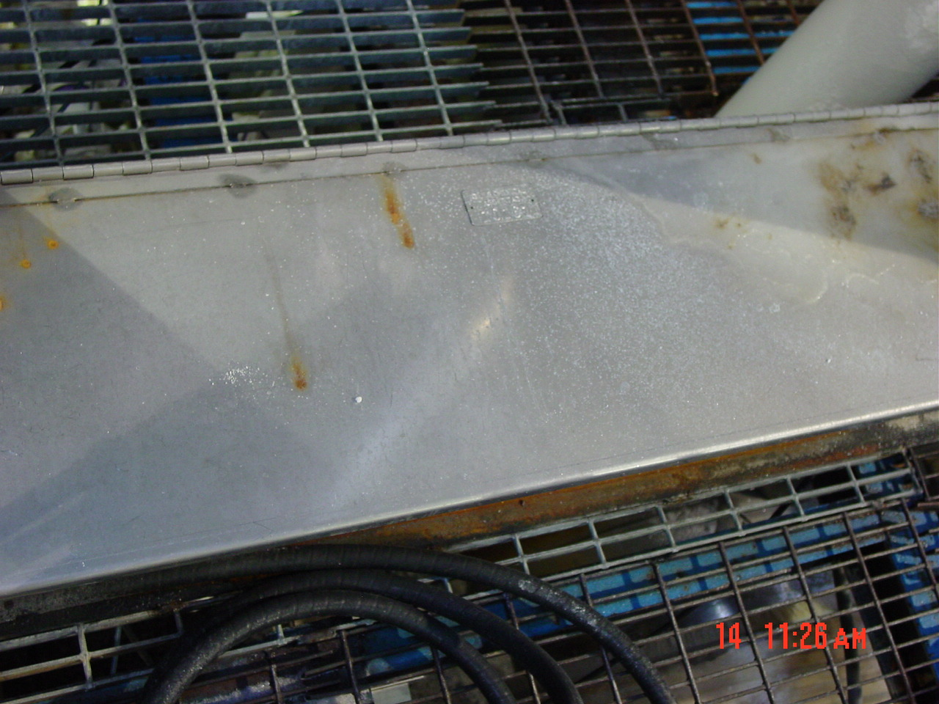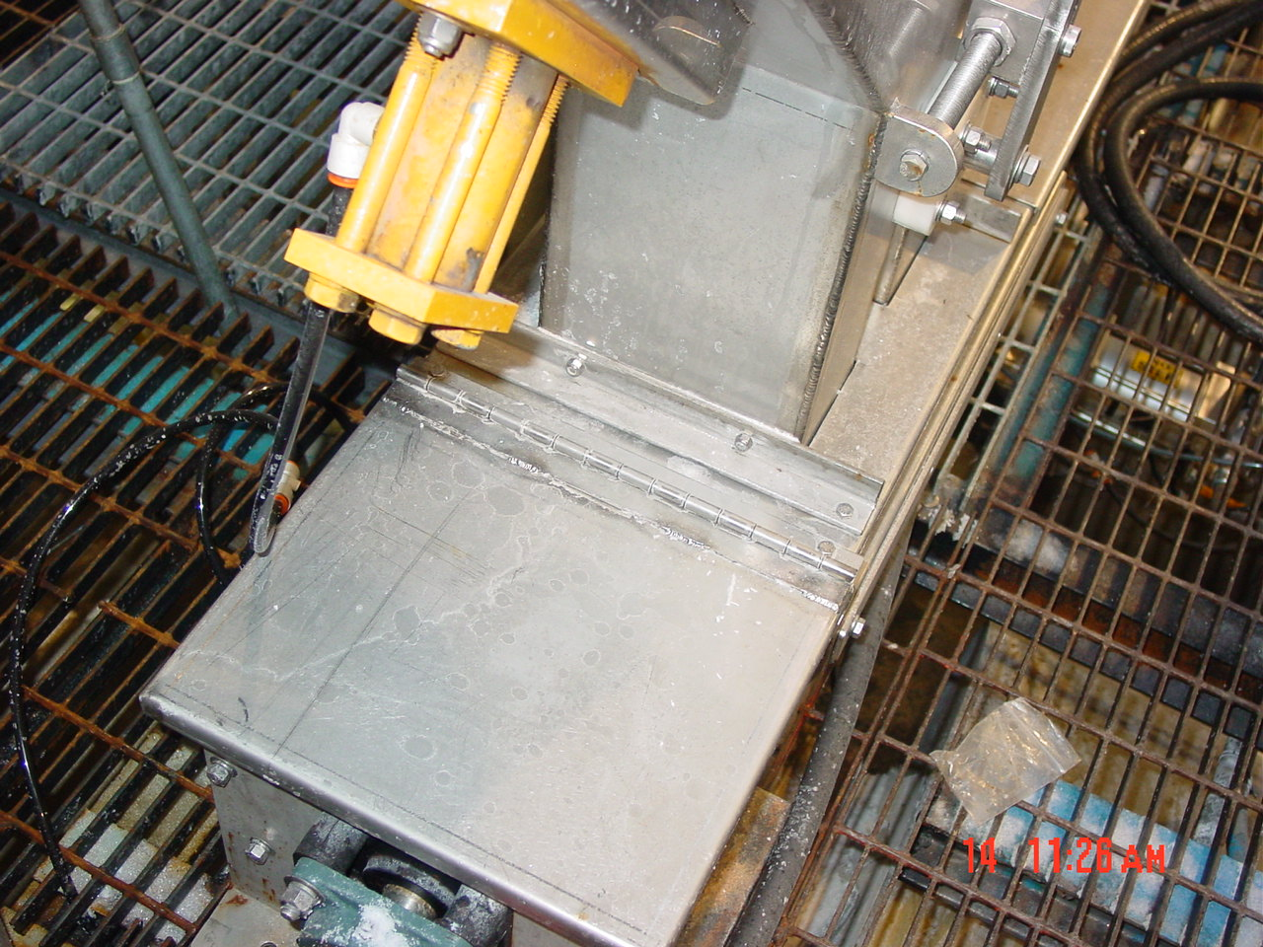
Figure 1 Figure 2
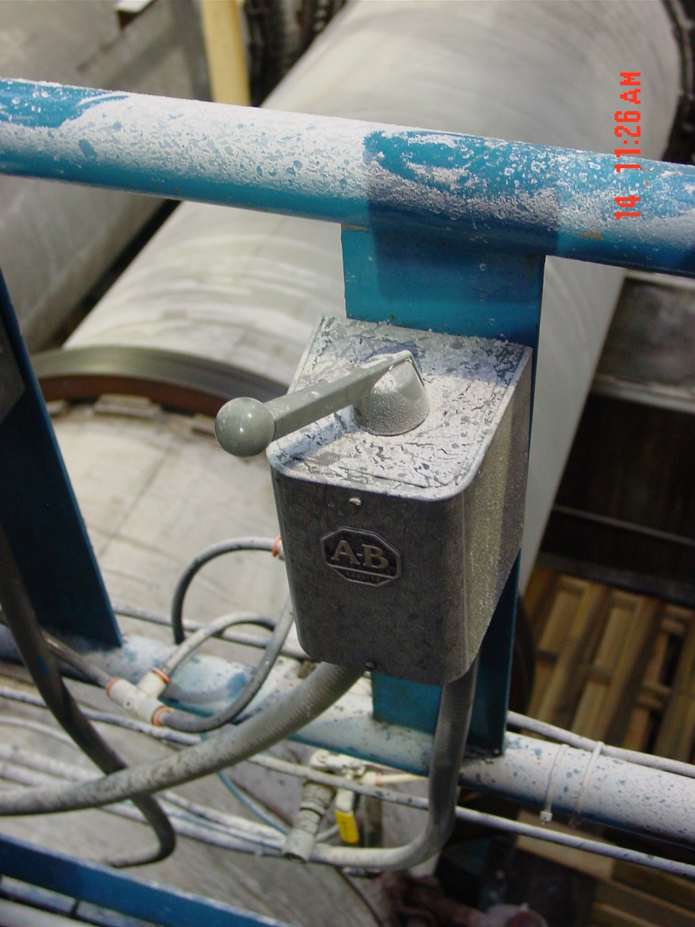
Figure 3
- Housing wash should be repeated one more time (Figure 1) for two-three minutes to ensure salt flushed from back of centrifuge to front is removed.
Figure 1
- Confirm that screw has been returned to proper operation (forward or reverse) to match the current centrifuge in operation. Use selector switch to control operation.
- Turn off washout valve (Figure 1) and shut Mother Liquor pot valve (Figure 2) and open feed valves to the dryers.
Figure 1 Figure 2

- Re-divert centrifuge feed from the sample pot to the Centrifuge in operation.
- Make sure screw conveyor lids are closed, vibrators are operation, and system is in general working order.
- Reference Documents

N/A

- Change Information

New Document

